Homework 9

**Mission 1**

* View the Mailservers for Starwars:

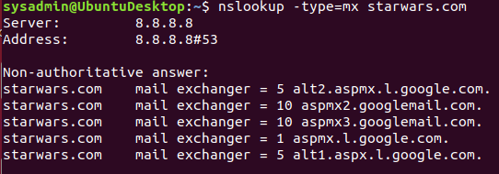

The Resistance isn’t receiving any emails because the new emails servers weren’t set up. The corrected DNS record should look like:

**starwars.com MX preference = 1, mail exchanger = asltx.l.google.com**

**starwars.com MX preference = 5, mail exchanger = asltx.2.google.com**

**Mission 2**

The SPF record, which contains a list of all the servers authorized to send emails from a particular domain, shows that the new mailserver IP is not listed in the SPF record as an authorized sender and this is why users are still aren’t able to receive emails from theforce.net.

The SPF record shows: **v=spf1 a mx mx:smtp.secureserver.net include:aspmx.googlemail.com ip4:104.156.250.80 ip4:45.63.15.159 ip4:45.63.4.215**

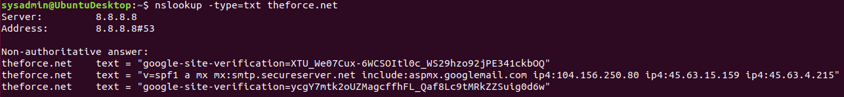

The SPF record should include the new IP of theforce.net (45.23.176.21):

**v=spf1 a mx mx:smtp.secureserver.net include:aspmx.googlemail.com ip4:45.23.176.21 ip4:104.156.250.80 ip4:45.63.15.159 ip4:45.63.4.215**

**Mission 3**

To figure out why the users aren’t able to be automatically redirected from their subpage of resistance.theforce.net to theforce.net, I ran an NS Lookup to view the CNAME (Canonical Name) record which maps a subdomain to the domain hosting the subdomain’s content.

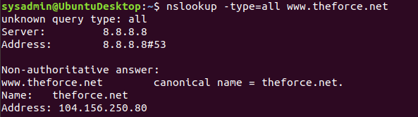

From the NS Lookup, it appears that there isn’t a CNAME for resistance.theforce.net. It should be added and should look like:

**resistance.theforce.net CNAME theforce.net**

**Mission 4**

The current NS record shows:

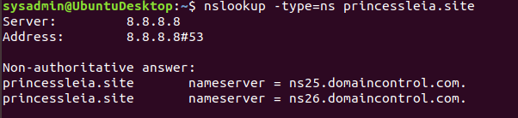

To add the backup DNR server provided by The Resistance’s networking team and to ensure that there is no significant downtime during an attack:

princessleia.site nameserver = ns26.domaincontrol.com

princessleia.site nameserver = ns25.domaincontrol.com

**princessleia.site nameserver = ns2.galaxybackup.com**

**Mission 5**

To improve the very slow network traffic, I looked for the shortest OSPF path from Batuu to Jedha that doesn’t include Planet N which appears to be under attack by the Empire and which is causing the slowness.

Based on the Galaxy Network Map, it is: **Batuu > D > C > E > F > J > I > L > Q > T > V > Jedha**

**Mission 6**

* Figure out the Dark Side’s secret wireless key by using Aircrack-ng. Secret wireless key: **dictionary**

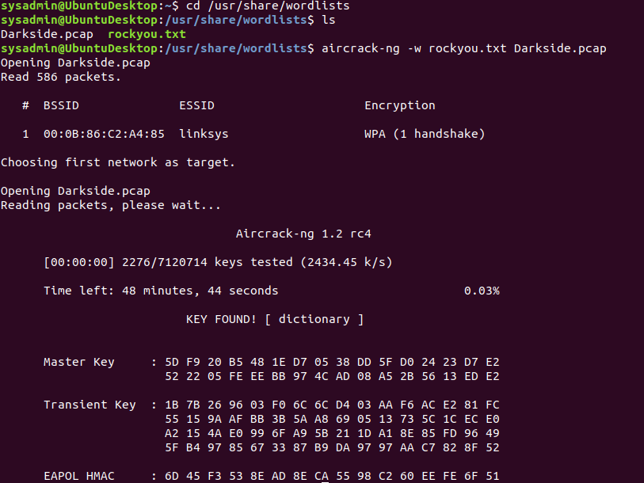

* Decrypt the pcap

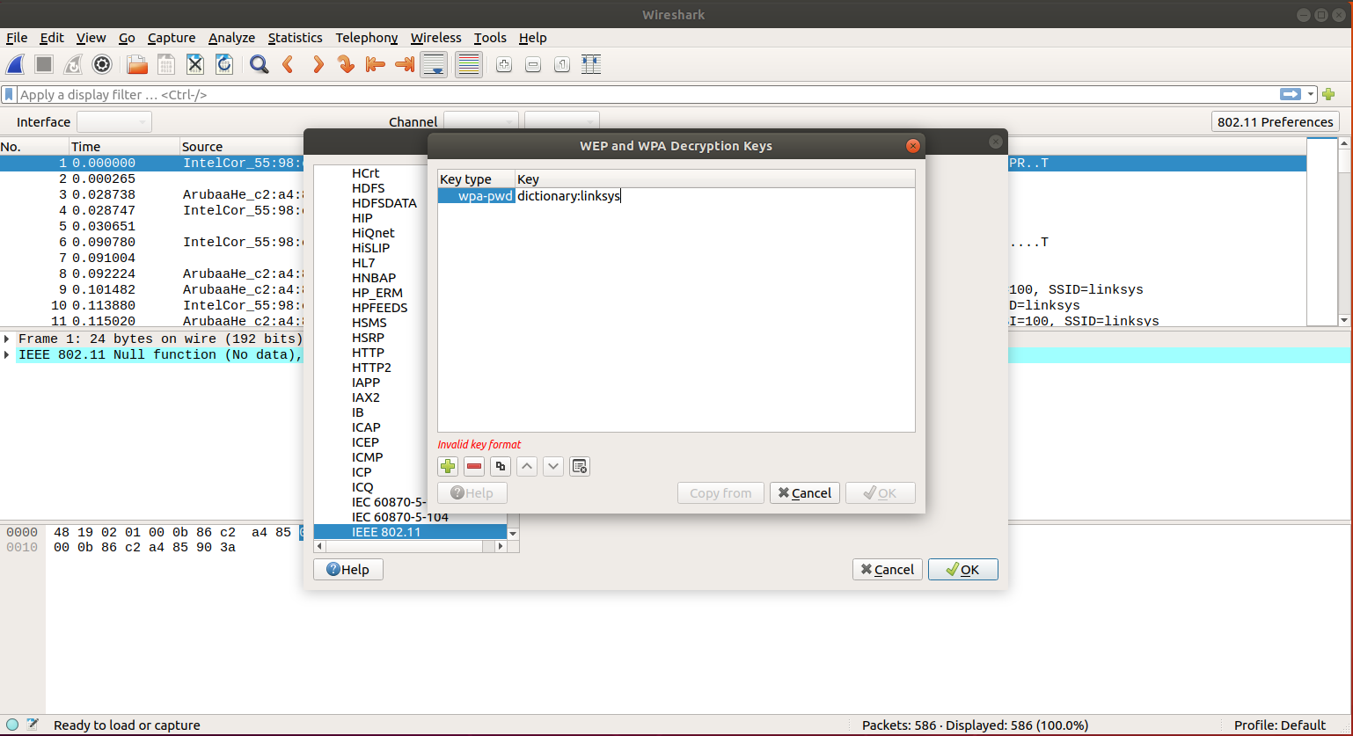

* Figure out the host IP addresses and MAC addresses

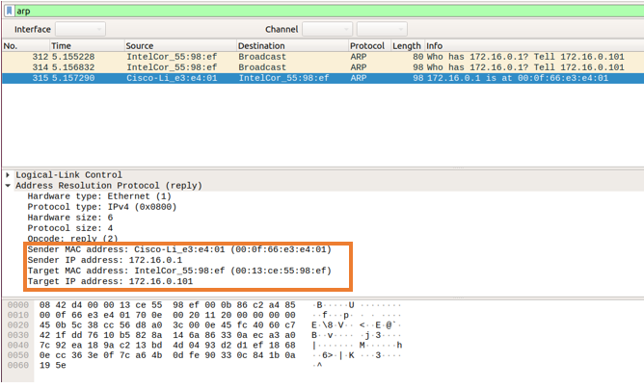

**Mission 7**

To view the hidden message in the TXT record from Mission #4, I ran **nslookup -type=txt princessleia.site**

